**Exercise 3: Stored Procedures**

Scenario 1: The bank needs to process monthly interest for all savings accounts.

o Question: Write a stored procedure ProcessMonthlyInterest that calculates and updates the balance of all savings accounts by applying an interest rate of 1% to the current balance.

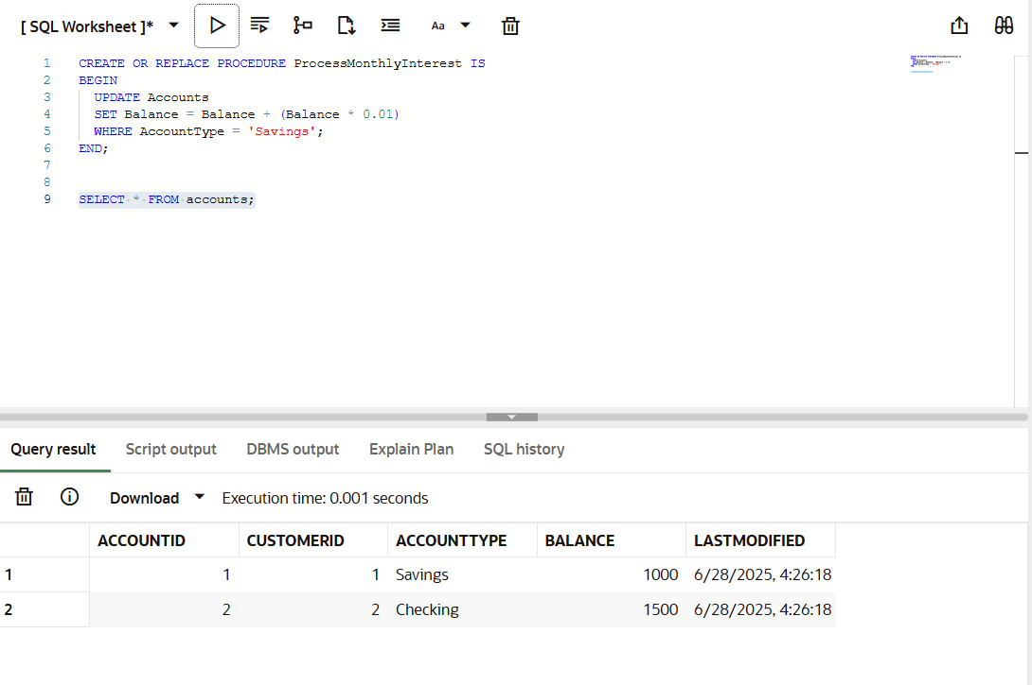

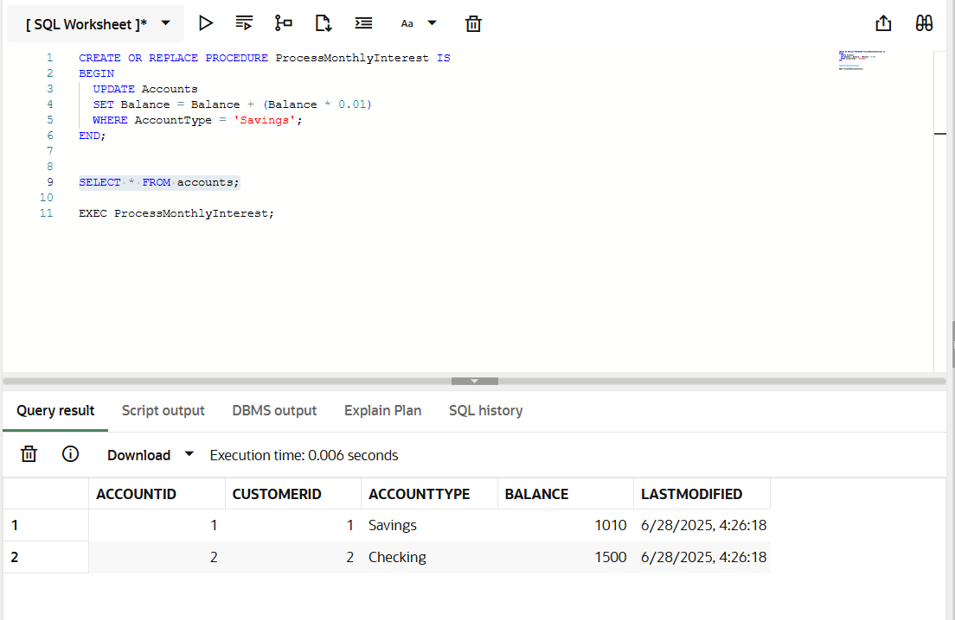

**Objective**:  
Create a stored procedure that applies 1% interest to the balance of all savings accounts (i.e., AccountType = 'Savings').

**Key Concepts**:

* Uses a single UPDATE statement
* Applies logic to all applicable rows
* Executed procedure using exec followed by procedure name

Scenario 2: The bank wants to implement a bonus scheme for employees based on their performance.

o Question: Write a stored procedure UpdateEmployeeBonus that updates the salary of employees in a given department by adding a bonus percentage passed as a parameter.

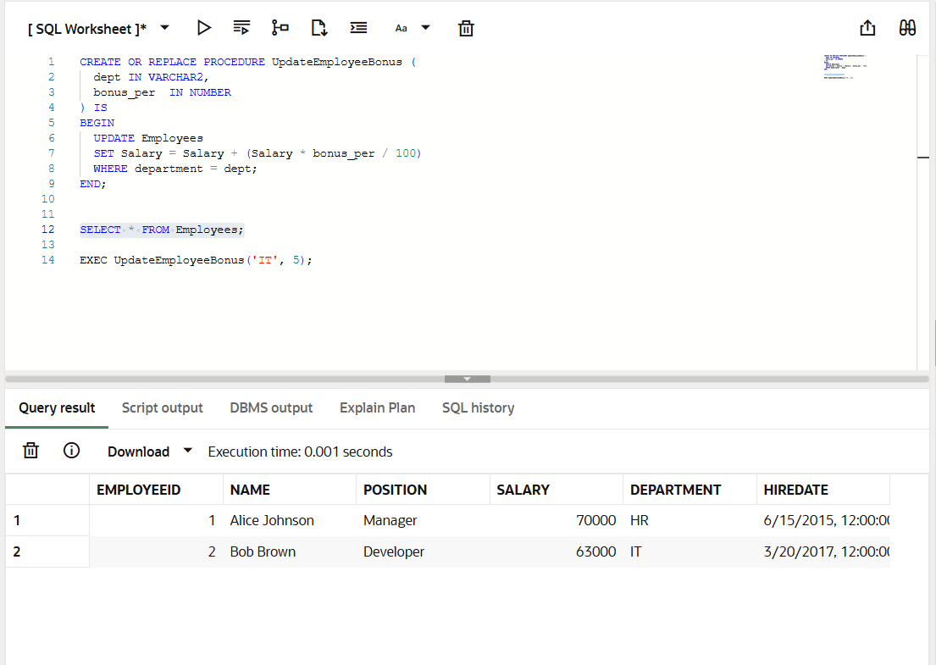

**Objective**:  
Create a procedure that adds a bonus percentage to the salary of employees in a specific department. The department name and bonus % are passed as input parameters.

**Key Concepts**:

* Uses IN parameters
* Conditional update based on Department
* Executed using EXEC followed by procedure name

Scenario 3: Customers should be able to transfer funds between their accounts.

o Question: Write a stored procedure TransferFunds that transfers a specified amount from one account to another, checking that the source account has sufficient balance before making the transfer.

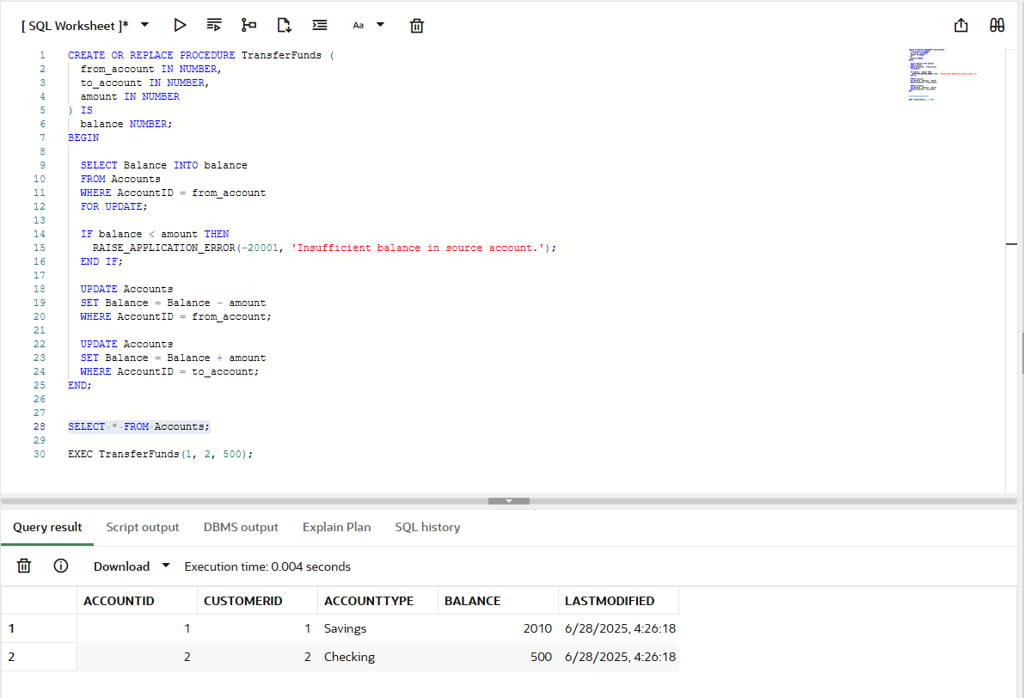

**Objective**:  
Create a stored procedure that transfers a specific amount from one account to another. It must validate that the source account has enough balance before performing the transfer.

**Key Concepts**:

* Input parameters for FromAccount, ToAccount, and Amount
* Validation with IF condition
* Safe money transfer using two UPDATE statements
* Use of RAISE_APPLICATION_ERROR for handling insufficient balance